Name: K. Siri Chandana

HT.NO: 2403A51282

Lab5.4:

Lab5.4_1:

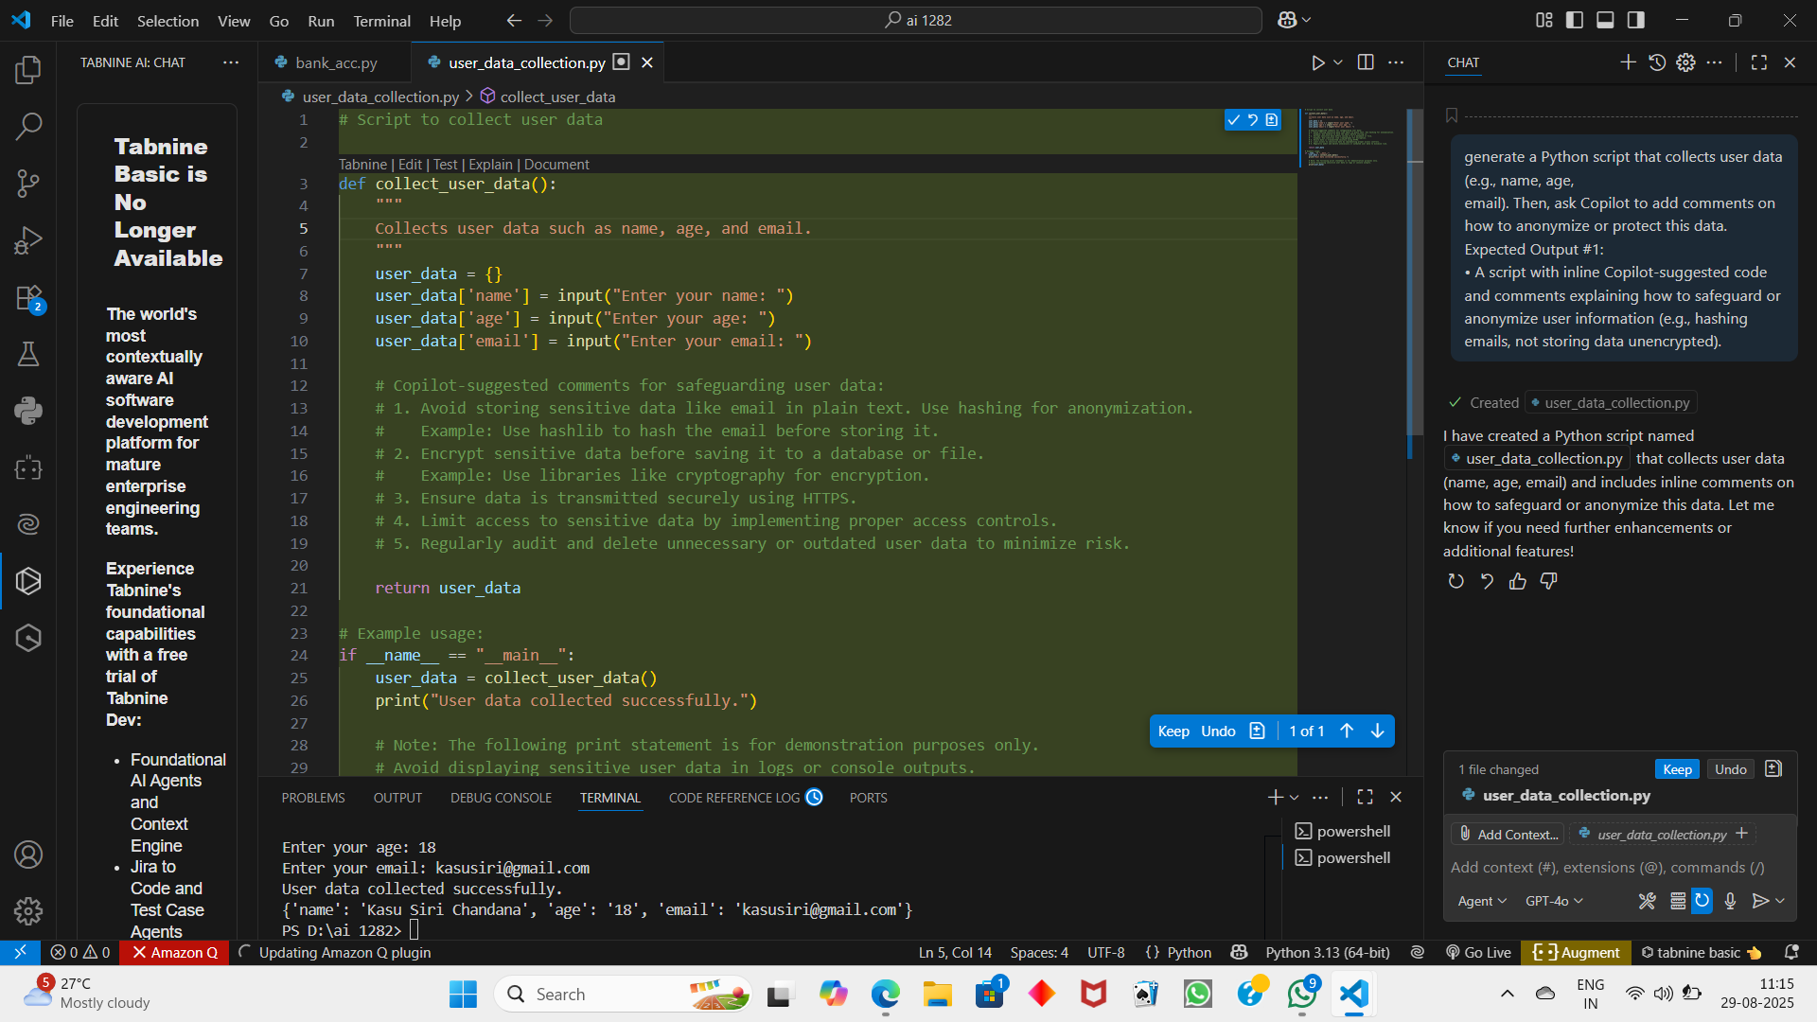

Output:

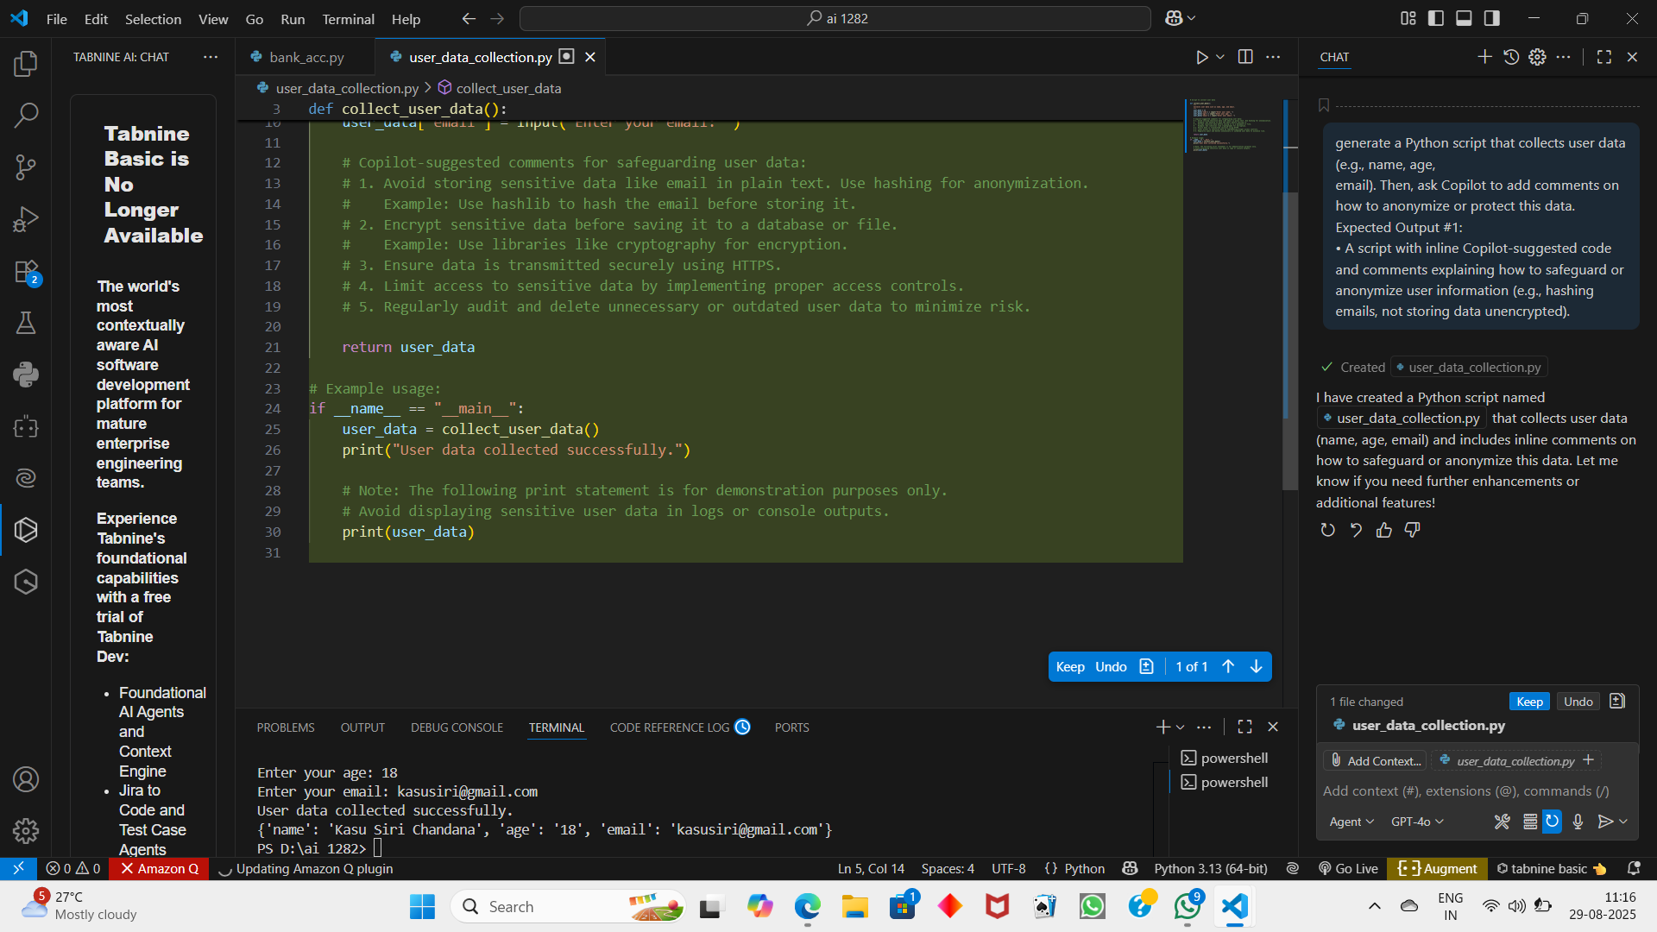

Lab5.4_2:

Output:

Lab5.4_3:

Output:

Lab5.4_4:

Output:

Lab5.4_5:

Output:

